David Sherrill’s step-by-step guide to getting into your live virtual talk / presiding session
(I am basing this on how things worked in the Spring meeting, and what I can test so far for the Fall meeting. The system is not 100% online yet so there are some things I can’t test!)
No Zoom Links. Instead, a Meeting Platform.
There aren’t any Zoom links being made available to me or anyone. So, we can’t send you a Zoom link to your talk, even though the live virtual talks will be run via Zoom. The Zoom links are ‘hidden’ behind a “Virtual Platform” or “Meeting Platform” website. The only way to get into the sessions is to go in via that Meeting Platform. And the only way to get into that is to be registered for the meeting. If you changed your presentation from in-person to virtual, ACS advises you to call ACS Member Services to change your registration status (800-333-9511 or service@acs.org) . This will save you some money, and may or may not trigger their database to understand that you will be giving your talk virtually. (Speakers originally scheduled to give a talk in-person in a non-broadcast room, i.e., Ultrafast Vibrational Spectroscopy- New Methods and Applications, cannot give a live virtual talk … it could only be pre-recorded, and the deadline for pre-recording talks is Aug 20).
(Note: We had a miscommunication between PHYS and ACS about the registration codes for symposium organizers. You need to be registered for the full meeting. If you used the registration code and it only allowed you to register for one day, you need to call ACS Member Services and correct your registration to full meeting (PHYS can reimburse Symposium Organizers for this).)
How to Log in to the Meeting Platform
- Go to the Meeting Platform website: https://acs.digitellinc.com/acs/live/21/page/411
(note: you can also get here by going to https://acs.org , then clicking on the large “ACS Fall 2021” banner, and then clicking the yellow button “Meeting Program”)
- Click on the “Login” blue button in the upper right corner of the screen
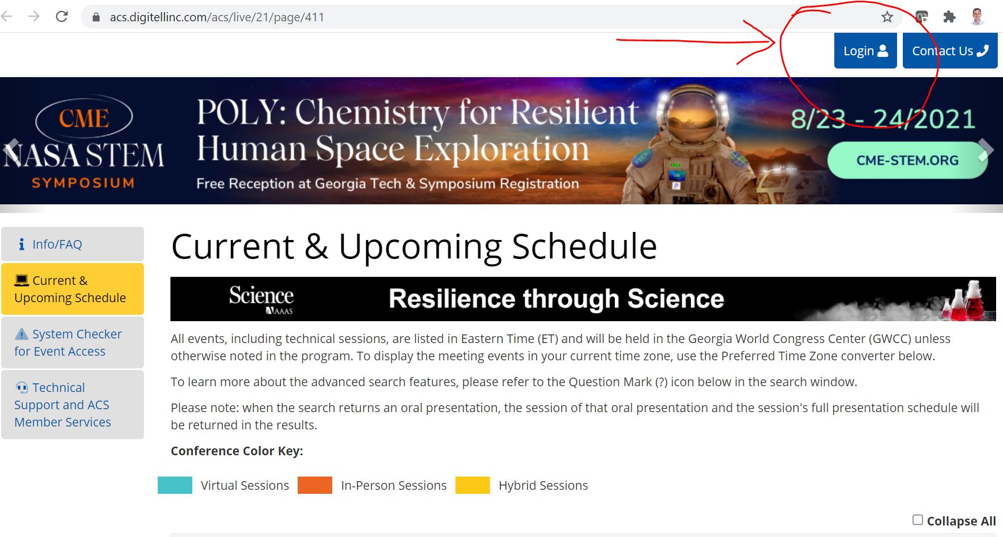
- Log in using your ACS ID and password. Hopefully this is the same ACS ID you used when you registered, and is associated with the same email you used when you submitted your abstract. If there are any mismatches, ACS may get confused about “duplicate accounts” and may not associate the correct info with your Meeting Platform. If you suspect this has happened (e.g., you registered but it won’t let you log in, or you log in and you can’t find your talks (below)), call ACS Member Services, 800-333-9511 (or service@acs.org)
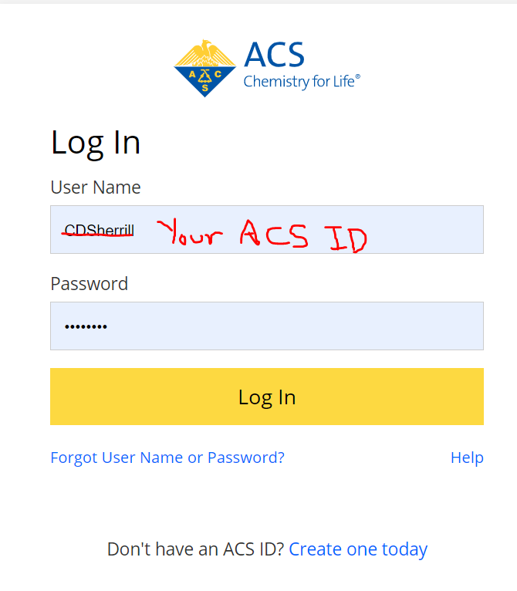

Find Talks/Symposia Associated with You as a Speaker or Session Presider
- Once in the platform, you can find the schedule, which can be filtered by Division, etc. You can use this later to look for other talks and sessions you might be interested in attending. But for now, pull up the information associated with your account by clicking the blue “My Account” button in the upper right
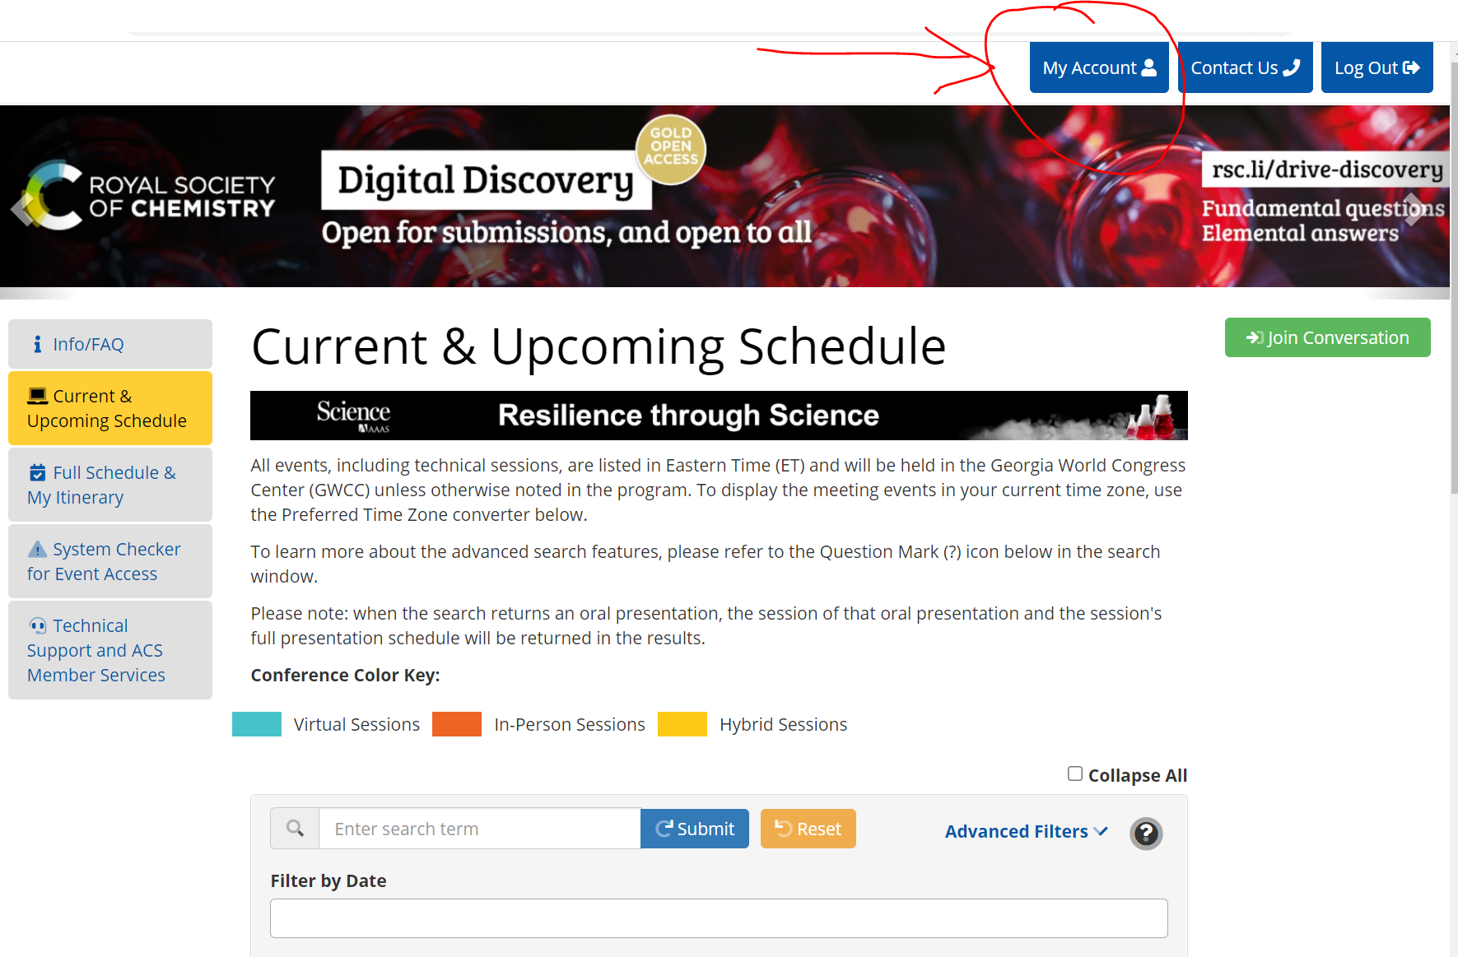
- This will open up your user profile in the Meeting Platform. When this screen comes up, click on the tab on the left labeled “Speaker Management”
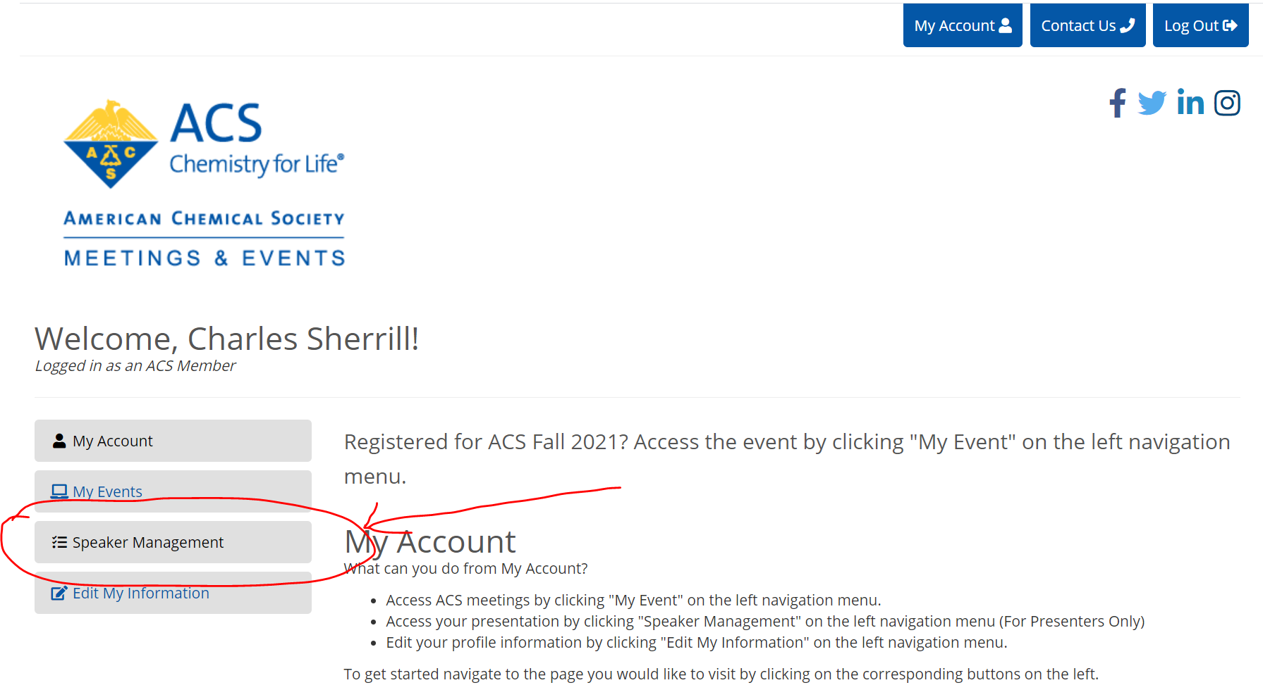
- Once you click Speaker Management, you should see the screen below. Under the “ACS Fall 2021 Oral Presentations,” hit the blue “Launch” button.
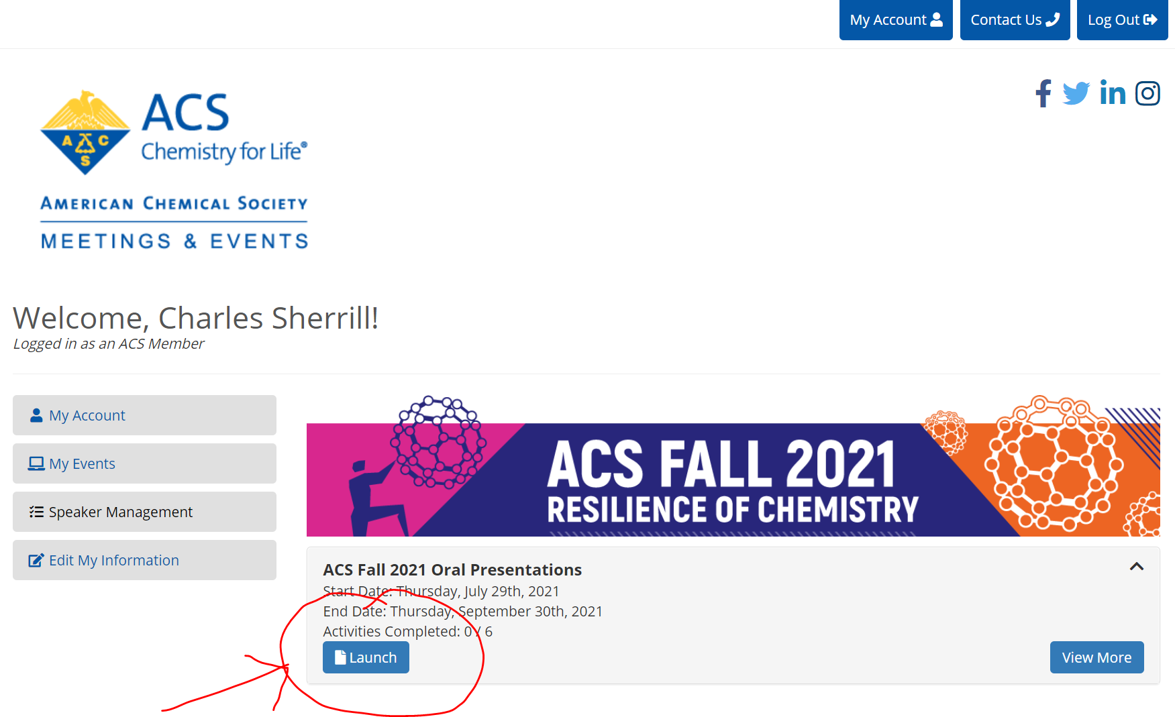

- On the left, you will see some tabs for various items they request that you do (update profile information, upload headshot). I think this pertains to on-demand talks and I’m not sure it’s critical. Do them if you want. To get to your list of talks & sessions moderated, click the “Enter Live Session” tab on the left.

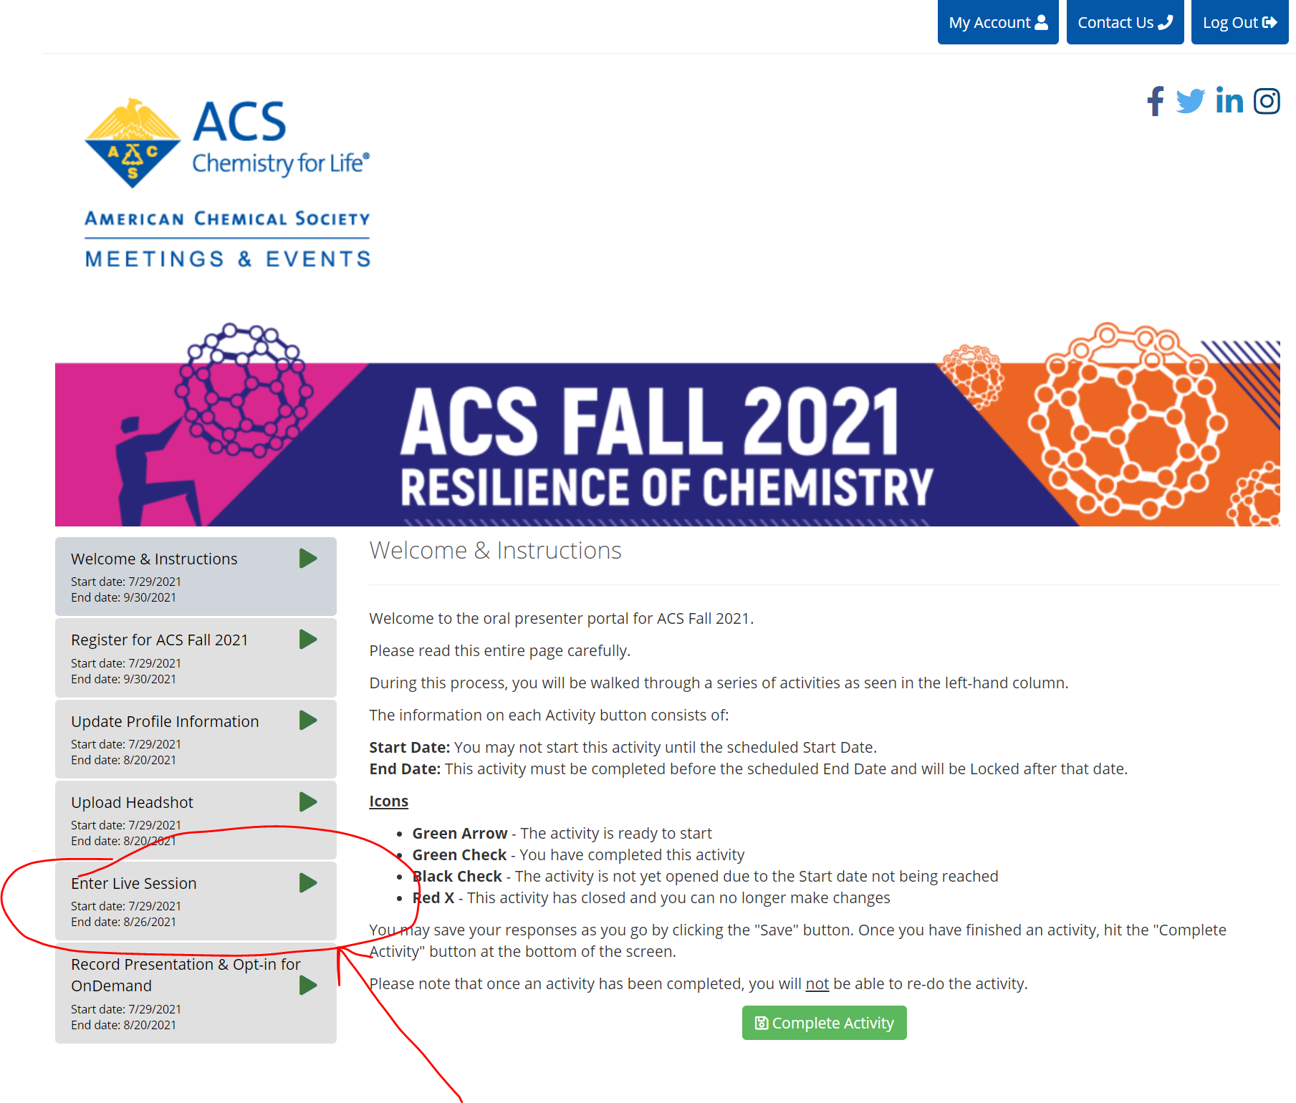

- This should bring up a list of all of your talks and sessions you are moderating. The light blue button “Join Session” should take you to the Zoom session. They won’t be active until around a half hour before the session starts, but you can click it now just to test that it tries to take you somewhere. If you see all your talks and sessions moderated here, you should be good to go! If not, please let me know or contact abstracts@acs.org.
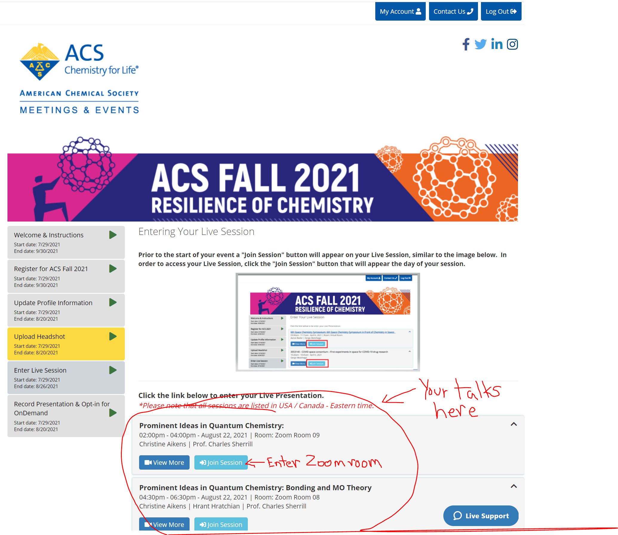

Presiders: Please enter your Zoom room 25 minutes early. Once in the Zoom room, please change your name to “Presider – [insert your name here]”. This will help identify you to the ACS Producers.
Presenters: Please enter your Zoom room 20 minutes early.

