David Sherrill’s step-by-step guide to getting into a virtual symposium
No Zoom Links. Instead, a Meeting Platform.
There aren’t any Zoom links being made available, because ACS wants to make sure that all participants have paid their registration fees. So, you’ll have to log into the Meeting Platform before you can find your way to any of the virtual symposia. And you can’t log into the Meeting Platform unless you’ve registered first.
How to Log in to the Meeting Platform
- Go to the Meeting Platform website: https://acs.digitellinc.com/acs/live/21/page/411
(note: you can also get here by going to https://acs.org , then clicking on the large “ACS Fall 2021” banner, and then clicking the yellow button “Meeting Program”)
- Click on the “Login” blue button in the upper right corner of the screen
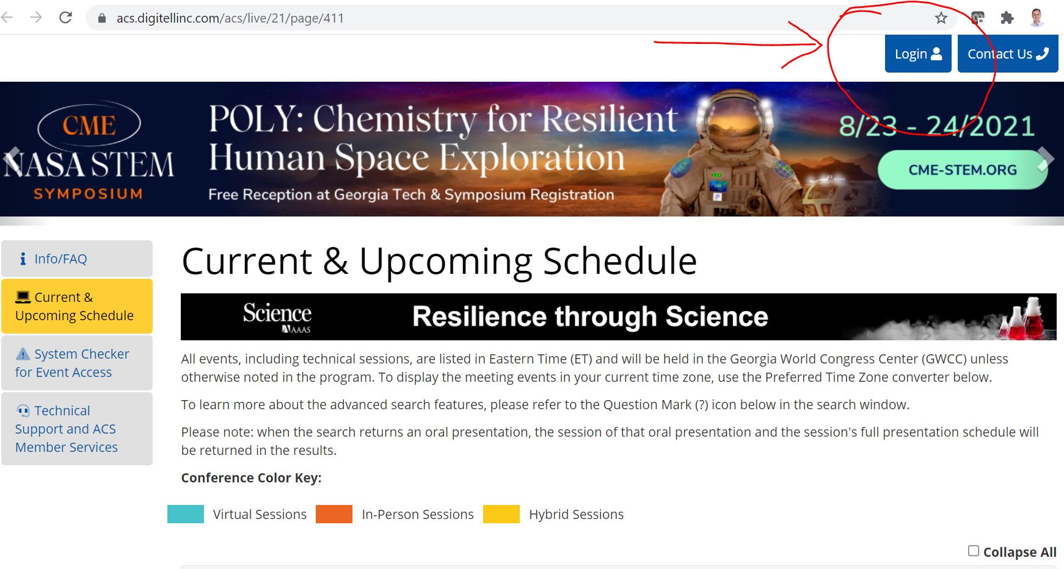

- Log in using your ACS ID and password. Hopefully this is the same ACS ID you used when you registered, and is associated with the same email you used when you submitted your abstract. If there are any mismatches, ACS may get confused about “duplicate accounts” and may not associate the correct info with your Meeting Platform. If you suspect this has happened (e.g., you registered but it won’t let you log in, or you log in and you can’t find your talks (below)), call ACS Member Services, 800-333-9511 (or service@acs.org)
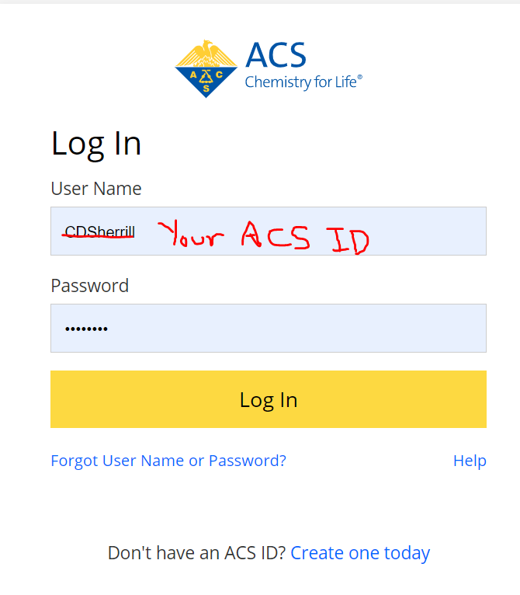

Find the Symposium You Want to Attend
Once you’ve logged in, you should land back on a “Current & Upcoming Schedule” Page. This is where you want to be. (Note Yellow tab “Current & Upcoming Schedule” highlighted on the left). This page is not well designed by the meeting platform vendor. I have messed with it, and find the search function extremely poor. I suggest you find your symposium with the approach below, which will hopefully reduce frustration.
- Click on the word “Advanced Filters” on the right side. This will open up some boxes you can use to refine your search.
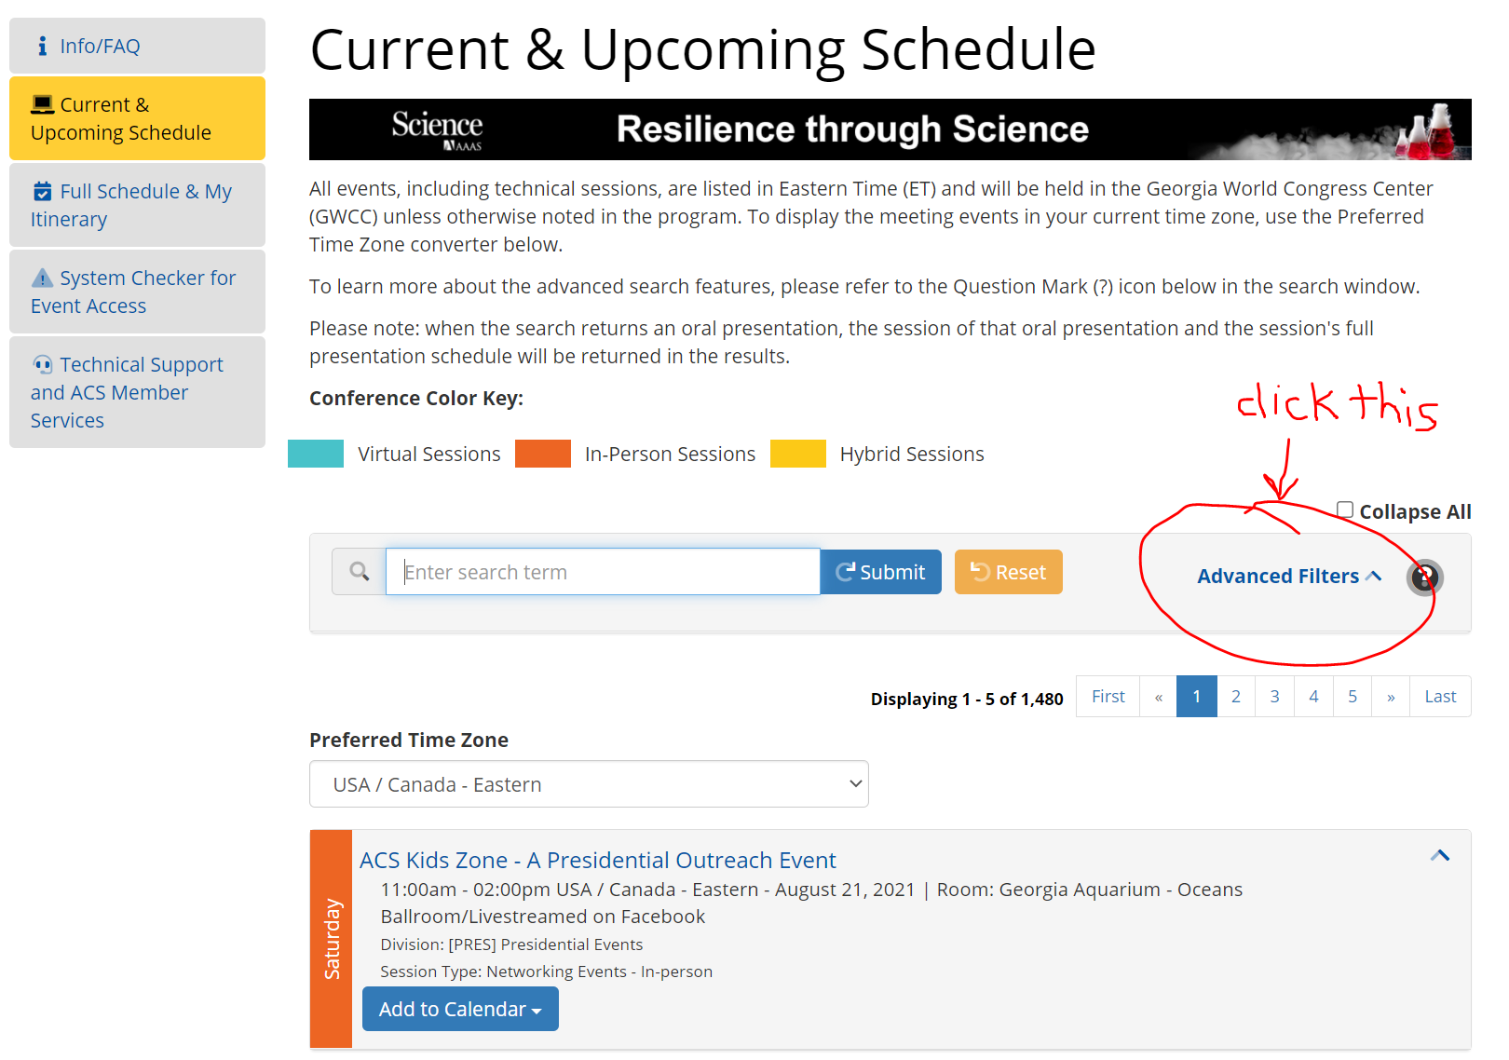

- It is generally helpful to filter by Division. Click the Division box and select the desired option, or bring it up by starting to type the name of the division. 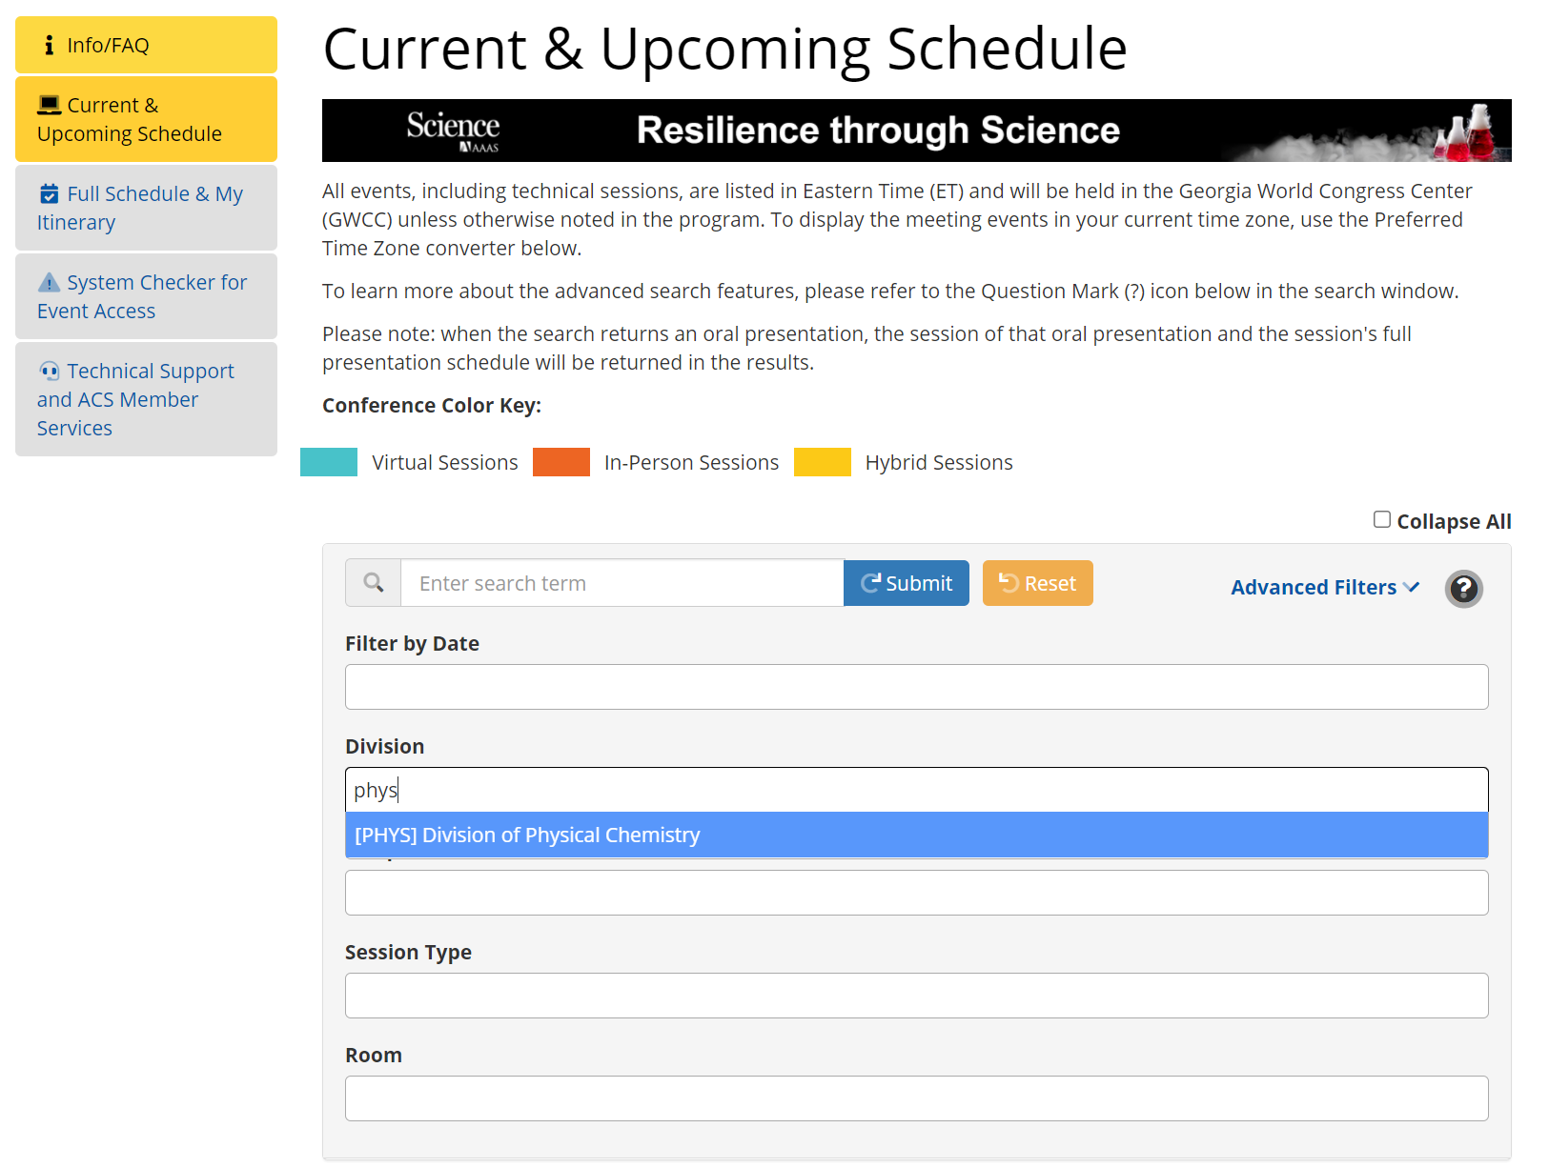

- This should now list all the Division-sponsored symposia that are running the day you do the search (or the next meeting day for which programming hasn’t already occurred). You should be able to see the symposium you are looking for in this list (it might be long, scroll down). You can hit the yellow “Join Virtually” button to get into the Zoom meeting a few minutes before the session starts.
Of course, you can also search by author name, etc., for a particular talk. I tried searching by symposium name, but often got what I wanted plus a lot of clutter I didn’t want, including entire abstracts for every match.
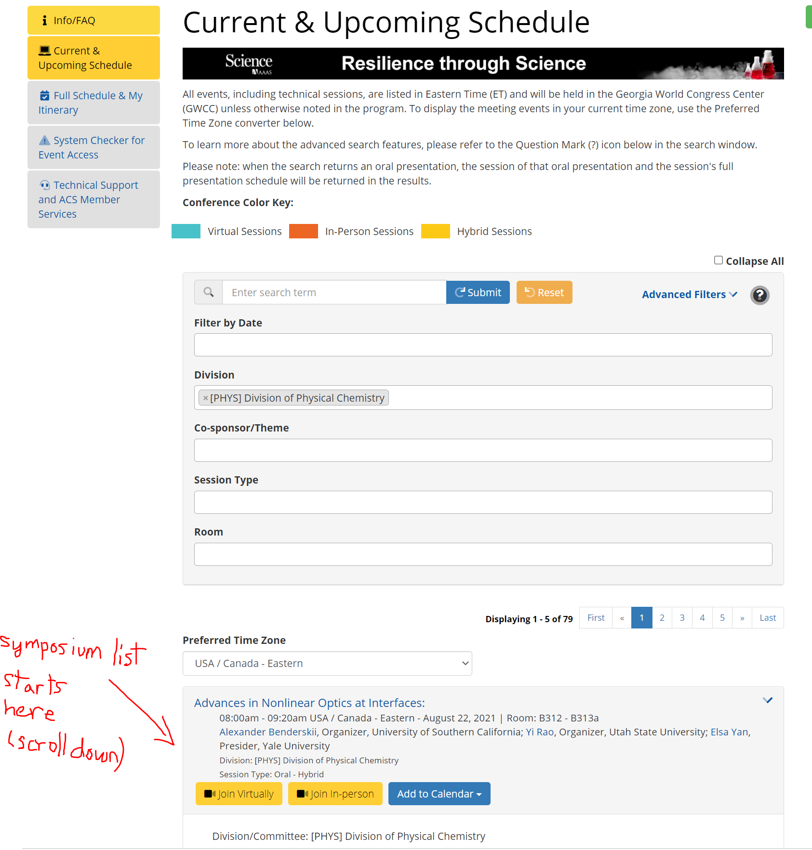
- If you like to plan ahead, you can do similar things using the “Full Schedule & My Itinerary” Tab on the left. You can search for symposia or talks you are interested in, and add them to your itinerary with the green “+Add to Itinerary” button. Then, each time you log in you can check your itinerary by coming back to this page and clicking on the “My Itinerary” button.

